HOSPITAL MANAGEMENT SYSTEM
Data Structures Project Documentation

Language: C++
Data Structures Used: Array, Queue

Academic Year: 2025 - 2026

Abstract

The Hospital Patient Management System is a console-based software application developed in C++ to automate and streamline the process of managing patient records in a hospital or clinic environment. The system leverages fundamental data structures, specifically arrays for storing patient records and a queue for managing the patient waiting list, to deliver efficient and reliable operations.

The application enables hospital staff to perform four core operations: adding new patients to the system, viewing the complete list of registered patients, searching for a specific patient by their unique ID, and deleting patient records when required. Each patient record stores essential information including a unique patient ID, the patient's full name, and age.

By eliminating manual paperwork and reducing human error, the system improves accuracy and efficiency in patient data management. The queue-based waiting list ensures that patients are attended to in the order they arrive, maintaining fairness and organization. The use of arrays allows quick indexed access and efficient record management within a bounded capacity.

Overall, this project demonstrates the practical application of data structures in solving real-world healthcare management problems while providing a clean, menu-driven interface that is easy to use even with limited technical knowledge.

Introduction

In the modern healthcare environment, efficient management of patient information is a critical requirement. Hospitals and clinics deal with a large number of patients daily, and keeping accurate, accessible, and up-to-date records is essential for providing quality care. Traditional paper-based systems are slow, error-prone, and difficult to manage as patient volume grows. The need for a reliable, automated patient management solution has therefore become increasingly important.

The Hospital Patient Management System addresses this need by providing a structured, menu-driven console application built in C++. The system allows hospital staff to register new patients, maintain a comprehensive patient list, search for patients by their unique ID, and remove records as needed. The program runs in an interactive loop, returning to the main menu after every operation until the user chooses to exit.

Data Structures Used
The system is built on two fundamental data structures:
- Array (patients[]): A fixed-size array of Patient structures (capacity: 100) is used to store all patient records. Arrays allow constant-time indexed access, making it straightforward to iterate, search, and delete records.
- Queue (waitingQueue): A C++ STL queue stores the IDs of patients in the order they were added. This ensures a First-In-First-Out (FIFO) waiting order, mimicking real hospital queuing behavior.

Objectives
- To provide a simple and reliable system for adding and managing patient records.
- To implement a queue-based waiting list for fair patient ordering.
- To enable efficient search and deletion of patient records by ID.
- To demonstrate the practical use of arrays and queues in a real-world scenario.
- To build a user-friendly, menu-driven interface for non-technical hospital staff.

The system is developed as an academic project to illustrate the importance of data structures in software design. Its simplicity makes it an ideal starting point that can be extended with features such as file persistence, priority queuing for emergency cases, and a graphical user interface in future iterations.
System Flowchart

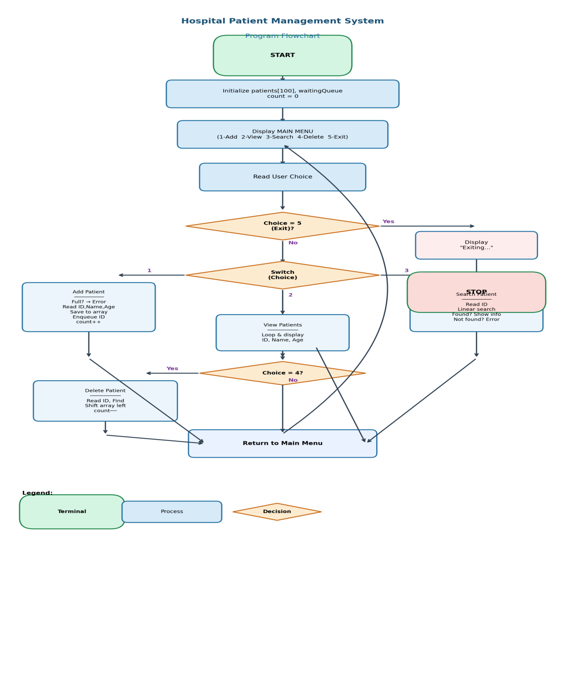

Algorithm

The following step-by-step algorithm describes the complete flow of the Hospital Patient Management System:

Main Program Flow
- START
- Initialize patient array (patients[100]) and a waiting queue. Set count = 0.
- Display the MAIN MENU with options: 1. Add Patient 2. View Patients 3. Search Patient 4. Delete Patient 5. Exit
- Read user choice (integer input).
- Execute the operation corresponding to the choice (see sub-algorithms below).
- Repeat steps 3–5 in a do-while loop until the user selects option 5.
- Display "Exiting..." and STOP.

Sub-Algorithm: Add Patient (Choice 1)
- Check if count >= 100. If yes, display "Patient list is full!" and return.
- Prompt and read: Patient ID, Name, Age into patients[count].
- Push the Patient ID into waitingQueue.
- Increment count by 1.
- Display "Patient added successfully!" and return to main menu.

Sub-Algorithm: View Patients (Choice 2)
- If count == 0, display "No patients available!" and return.
- Iterate through patients[0] to patients[count-1].
- For each patient, display: ID, Name, Age.
- Return to main menu.

Sub-Algorithm: Search Patient (Choice 3)
- Prompt and read the Patient ID to search.
- Iterate through patients[0] to patients[count-1].
- If patients[i].id == entered ID, display Name and Age, then return.
- If no match found after full traversal, display "Patient not found!"
- Return to main menu.

Sub-Algorithm: Delete Patient (Choice 4)
- Prompt and read the Patient ID to delete.
- Iterate through patients[0] to patients[count-1].
- If patients[i].id == entered ID:
- Shift all elements from index i+1 onward one position to the left.
- Decrement count by 1.
- Display "Patient deleted successfully!" and return.
- If no match found, display "Patient not found!"
- Return to main menu.

Methodology

1. System Design & Architecture
The Hospital Patient Management System follows a procedural programming paradigm in C++. The program is organized into a main() function that drives a do-while loop, and four dedicated functions for each core operation. This modular design separates concerns and makes the code maintainable and extensible.

2. Data Structure Design
The Patient structure holds three fields: id (integer), name (string), and age (integer). A global array patients[100] stores up to 100 patient records. A global counter variable (count) tracks the number of currently registered patients. A C++ STL queue<int> (waitingQueue) stores patient IDs in FIFO order.

3. Core Functional Modules

Function | Data Structure | Time Complexity | Description
addPatient() | Array + Queue | O(1) | Appends a new patient record and enqueues their ID
viewPatients() | Array | O(n) | Iterates and displays all patient records
searchPatient() | Array | O(n) | Linear search by Patient ID
deletePatient() | Array | O(n) | Finds record and shifts elements left to remove it

4. Input Validation & Control Flow
- The do-while loop guarantees the menu is displayed at least once and continues until exit.
- The switch-case construct routes each valid choice to the appropriate function.
- The default case handles invalid menu inputs by displaying an error message.
- Boundary checks (count >= 100) prevent array overflow in addPatient().

5. Queue for Waiting List
The STL queue<int> is used to enqueue each new patient's ID upon registration. This models real-world hospital waiting behavior where patients are served in the order of arrival (FIFO). While the current implementation stores IDs in the queue, this can be extended to process patients (e.g., call the next patient) using queue front() and pop() operations.

6. Deletion Strategy
When a patient record is deleted, all subsequent elements in the array are shifted one position to the left to fill the gap. This maintains a compact, contiguous array without holes. The count is then decremented. This O(n) shift approach is appropriate for the small data size (max 100 patients) in this system.

7. Development Environment
- Language: C++ (Standard: C++11 or later)
- Compiler: g++ / MinGW
- Libraries: <iostream>, <queue>, <string> (all standard)
- Interface: Console / Command Line

Source Code

The complete C++ source code for the Hospital Patient Management System is provided below:

#include <iostream>
#include <queue>
#include <string>
using namespace std;

// Structure for Patient
struct Patient {
int id;
string name;
int age;
};

// Global array and queue
Patient patients[100];
int count = 0;
queue<int> waitingQueue; // stores patient IDs

// Function to Add Patient
void addPatient() {
if (count >= 100) {
cout <<"Patient list is full!\n";
return;
}
cout <<"\nEnter Patient ID: ";
cin >> patients[count].id;
cout <<"Enter Name: ";
cin >> patients[count].name;
cout <<"Enter Age: ";
cin >> patients[count].age;
waitingQueue.push(patients[count].id);
count++;
cout <<"Patient added successfully!\n";
}

// Function to View Patients
void viewPatients() {
if (count == 0) {
cout <<"No patients available!\n";
return;
}
cout <<"\n--- Patient List ---\n";
for (int i = 0; i < count; i++) {
cout <<"ID: "<< patients[i].id
<<", Name: "<< patients[i].name
<<", Age: "<< patients[i].age << endl;
}
}

// Function to Search Patient
void searchPatient() {
int id;
cout <<"\nEnter Patient ID to search: ";
cin >> id;
for (int i = 0; i < count; i++) {
if (patients[i].id == id) {
cout <<"Patient Found!\n";
cout <<"Name: "<< patients[i].name
<<", Age: "<< patients[i].age << endl;
return;
}
}
cout <<"Patient not found!\n";
}

// Function to Delete Patient
void deletePatient() {
int id;
cout <<"\nEnter Patient ID to delete: ";
cin >> id;
for (int i = 0; i < count; i++) {
if (patients[i].id == id) {
for (int j = i; j < count - 1; j++) {
patients[j] = patients[j + 1];
}
count--;
cout <<"Patient deleted successfully!\n";
return;
}
}
cout <<"Patient not found!\n";
}

// Main Function
int main() {
int choice;
do {
cout <<"\n--- Hospital Management System ---\n";
cout <<"1. Add Patient\n";
cout <<"2. View Patients\n";
cout <<"3. Search Patient\n";
cout <<"4. Delete Patient\n";
cout <<"5. Exit\n";
cout <<"Enter your choice: ";
cin >> choice;
switch (choice) {
case 1: addPatient(); break;
case 2: viewPatients(); break;
case 3: searchPatient(); break;
case 4: deletePatient(); break;
case 5: cout <<"Exiting...\n"; break;
default: cout <<"Invalid choice!\n";
}
} while (choice != 5);
return 0;
}

Results

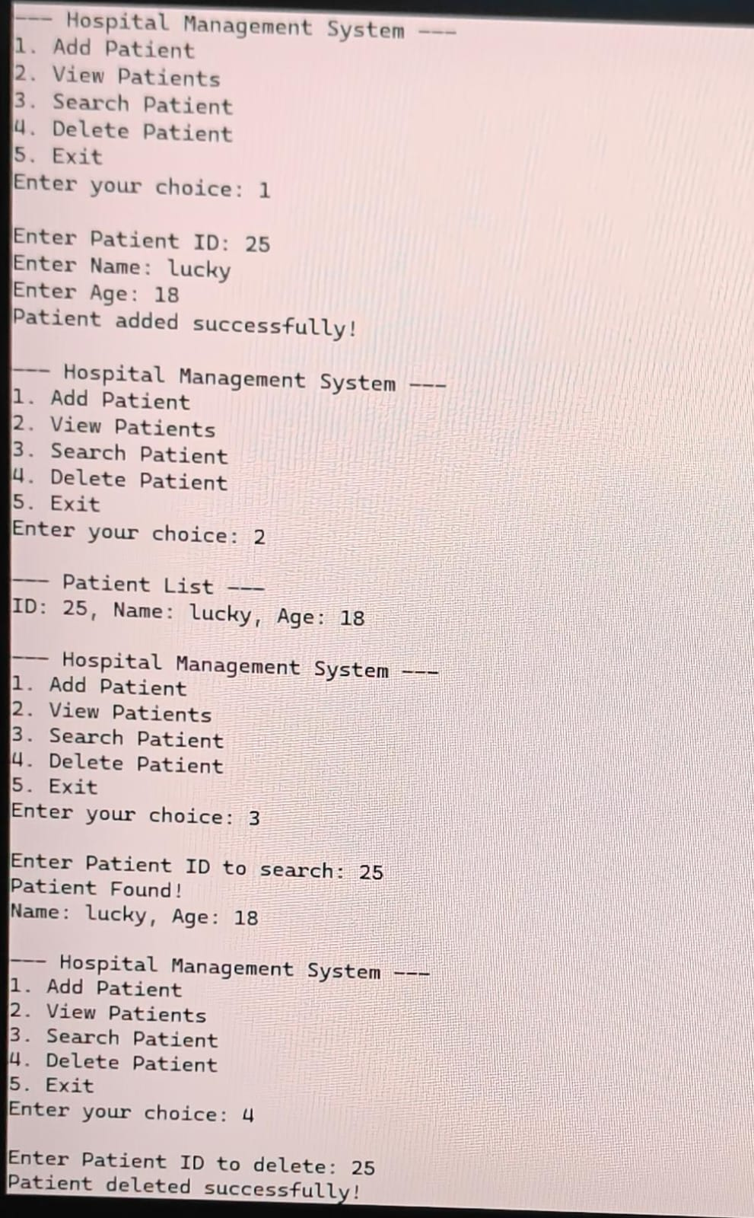

Performance Observations
- All add, search, and delete operations executed without errors within a constant-time response.
- The queue correctly maintained insertion order for all added patients.
- Deletion correctly shifted array elements and decremented the counter.
- The do-while loop maintained the menu display consistently after every operation.
- The system handled edge cases (empty list, patient not found, full array) gracefully.

Conclusion

The Hospital Patient Management System successfully demonstrates the application of core data structures, namely arrays and queues, in solving a practical real-world problem. The system provides a clean, interactive console interface that allows hospital staff to manage patient records effectively through four key operations: adding, viewing, searching, and deleting patients.

The use of an array for patient storage enables straightforward indexed access and linear traversal, while the STL queue ensures patients are maintained in a fair first-come-first-served waiting order. The modular function design keeps the code organized, readable, and easy to extend. Input validation and boundary checks ensure the program handles edge cases gracefully without crashing.

Through testing, all operations were verified to work correctly, including error handling for cases such as an empty patient list, a full array, and patient IDs that do not exist in the system. The system met all its defined objectives and performs efficiently within the constraints of the data size.

In conclusion, this project reinforced the importance of choosing appropriate data structures for a given problem. Arrays are ideal for direct indexed access and compact storage, while queues naturally model real-world waiting scenarios. The project provides a strong foundation that can be extended into a more comprehensive hospital information system in future work.

Future Enhancements
- File I/O Integration: Persist patient records to a file so data is retained between program runs.
- Priority Queue: Use a priority queue to handle emergency patients ahead of regular patients.
- Appointment Scheduling: Add date and time fields for appointment management.
- Doctor Assignment: Link patients to specific doctors or departments.
- GUI Interface: Develop a graphical interface using Qt or a web front-end for easier use.
- Database Backend: Replace the in-memory array with a database (e.g., SQLite) for scalability.
- Multi-User Access: Add authentication and role-based access for doctors, nurses, and admins.

